Trade of Metal Fabrication
Module 4: | Structural Steel Fabrication
Unit 3: | Guard Rail
 | Phase 2

Table of Contents
List of Figures 4
List of Tables 4
Document Release History 5
Module 4 – Structural Steel Fabrication 6
Unit 3 – Guard Rail 6
Learning Outcome: 6
Key Learning Points: 6
Training Resources: 7
Key Learning Points Code: 7
Galvanising, Painting & Shot Blasting 8
Surface Preparation 10
Pickling 10
Blast Cleaning 11
Flame Descaling 12
Metal Degreasing 12
Surface Protection of Materials 15
Painting 15
Surface Preparation Methods 16
Priming 16
Finishing Coats 16
Methods of Applying Paint 17
Maintenance 17
Metallic Coating 17
Hot Dip Galvanising 17
Tin Plating 17
Metal Spraying 17
Self Assessment 18
Index 19

List of Figures
Figure 1 - Surface Preparation 10
Figure 2 - Pickling 11
Figure 3 - Blast Cleaning 11
Figure 4 - Standard Vapour Degreasing Plant 14
Figure 5 - Operating a Shot Blast Requires Protective Clothing 15

List of Tables
Table 1 - Metallic Corrosion-Resistant Coatings 8
Table 2 - Non-Metallic Corrosion-Resistant Coatings 9

Document Release History
Date | Version | Comments
31/01/07 | First draft
13/12/13 | SOLAS transfer

Module 4 – Structural Steel Fabrication

Unit 3 – Guard Rail
Duration – 12 Hours

Learning Outcome:
By the end of this unit each apprentice will be able to:
- Read and interpret drawing
- Set up to obtain bevel angles
- Mark out rectangular and square hollow section
- Mark out and drill base plate, oxy-fuel gas cut
- Assemble, tack and weld a guard rail

Key Learning Points:
Rk Sk | Setting out, marking out, cutting, drilling, assembly, welding.  (For more information see Module 1 Unit 13).
Rk M | Measurement.  (For more information see Module 1 Unit 2).
Rk | Hand and guard rails, cat walks, gangways.
Rk | Galvanising, painting, shotblasting.
Rk | Hand rails, materials used.
Rk | M.A.G.s welding process.  (For more information see Module 2 Unit 10).
Rk | Assembly – opposite hand (right and left hand).  (For more information see Module 3 Unit 1).
Rk M | Powers and roots – correct use of tables.  (Instructor will explain in class).
Rk M | Use of calculator.  (Instructor will explain in class).
P | Standard of work, maintenance of work area, safety awareness.

Training Resources:
Fabrication workshop facilities, apprentice toolkit, P.P.E.

Key Learning Points Code:
M = Maths D= Drawing RK = Related Knowledge Sc = Science
P = Personal Skills Sk = Skill H = Hazards

Galvanising, Painting & Shot Blasting
Type of Coating | Method of Application
Hot dipping | Mild steel sheet is dipped into molten tin (tinplate), or into molten lead/tin alloy (terneplate), or into molten zinc (galvanised sheet).
Electro-Plating | Corrosion-resistant and decorative metals are electrolytically deposited upon a base metal. Generally the coatings are thinner and less protective than those produced by hot dipping.
Cladding | Produced by hot-rolling a composite slab of base metal and a corrosion-resistant metal, e.g. ALCLAD.
Spraying | Coatings of aluminium, brass, bronze, copper, lead, tin and zinc may be applied to the surfaces of a base metal by spraying. The coating metal in wire form is melted in a pistol (spray gun) and is impinged onto the required surfaces by a jet of compressed air.
Cementation | - Calorising - Components are baked in aluminium dust at 850-1000°C for several hours.  - Chromising - Components are baked in aluminium and chromium dust in an atmosphere of hydrogen at 1300°C for 3 to 4 hours.  - Sheradising - Components are baked in zinc dust at 350°C-370°C for up to twelve hours.
Table 1 - Metallic Corrosion-Resistant Coatings

Table 1 gives details of more permanent methods of corrosion prevention.

Type of Coating | Method of Application
Anodising | A hard oxide film is produced on the surface of aluminium by electrolysis in a chromic acid solution. For decorative purposes the film may be coloured by dyeing.
Chromating | A hard oxide film is formed on magnesium by dipping in a solution of potassium dichromate and sealing with zinc chromate paint.
Phosphating | Metallic phosphates are built up on the surfaces of a metal by immersion in suitable solutions. Phosphating is used extensively to prepare the steel panels of motor vehicles where it not only provides protection against corrosion but also provides a 'key surface' for painting. Bonderising, Granodising, Parkerising and Walterising are all phosphating processes.
Painting | First a 'primer' (containing a rust inhibitor such as lead oxide) is used on the metal surface to be protected and the protective coating is built up by one or more sealing coats. It is the only process that can readily be replaced in service.
Plastic | A protective coating may be built up by dipping the component into molten plastic, or by shrinking an envelope of plastic around the component.
Table 2 - Non-Metallic Corrosion-Resistant Coatings

Note: Protective coatings are often applied to metal components after fabrication, especially 'hot-dip galvanising'. This ensures that the protective coating is continuous, i.e. not broken at any point.

Surface Preparation
It has been firmly established that the essential and most important factor of any efficient anti-corrosion treatment is surface preparation.
However carefully selected the protective process may be, it cannot fulfil its purpose if it is applied to an ineffectively prepared surface. Surfaces carrying dirt, grease, corrosion or millscale are unsuitable for the direct application of an anticorrosion treatment. Figure 1 shows how the surface may be prepared for treatment.

Pickling
This is a chemical method of cleaning in which dilute sulphuric acid or mixed acids are used to clean the surface of metal as shown in Figure 2.
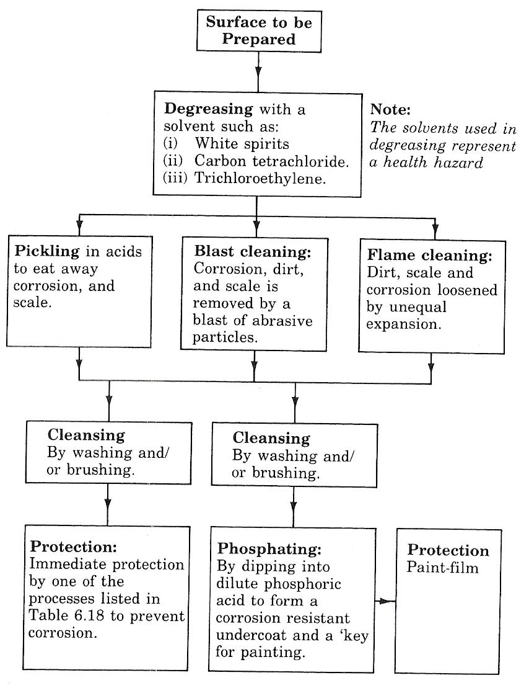
Figure 1 - Surface Preparation
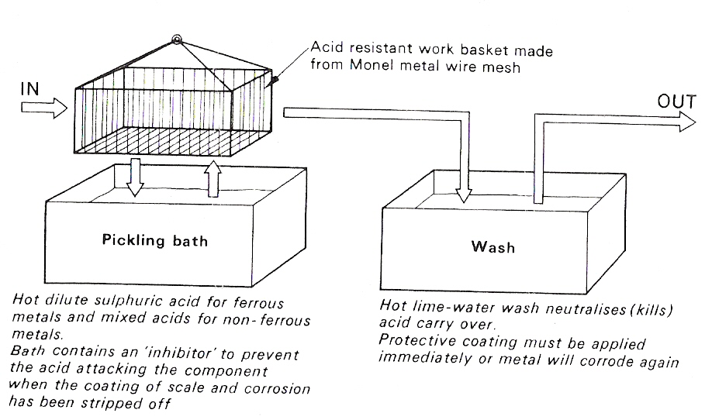
Figure 2 - Pickling

Blast Cleaning
This is a mechanical method of cleaning in which the scale and corrosion are dislodged by a high-velocity blast of abrasive particles as shown in Figure 3.
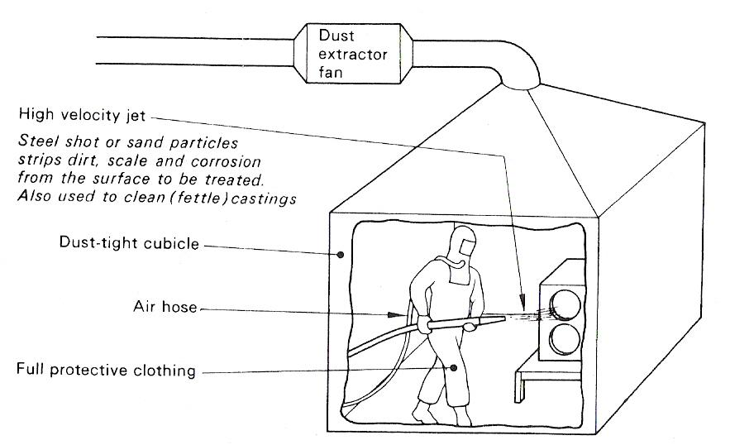
Figure 3 - Blast Cleaning

Flame Descaling
The effectiveness of this process depends upon the difference in expansion between the scale and base metal when subject to local heat.
The steel surface that is to be de scaled is heated with an oxy-fuel gas torch fitted with specially designed nozzles producing broad fan-shaped high-intensity flames. The rapid local thermal expansion of the loosely adhering scale against the relatively unheated base metal causes the former to flake off. The process is also assisted by the generation of steam by any moisture that may be trapped under or absorbed in the scale itself.
With this process rust removal is excellent - any rust particles are converted to powder which can easily be brushed away before commencing to paint, and a dry surface is ensured for 'priming' while the metal is still warm. For best results the primer should be applied when the steel is approximately 45°C that is the temperature at which the hand can be held comfortably on the steel.
Generally, flat nozzles which give a brush-like flame pattern are used for descaling flat surfaces and large areas which are free from projections, whilst round nozzles are used on all riveted and bolted areas, plate edges, corners, recesses and other places where it is not possible to operate flat nozzles effectively.
This method is often specified for the cleaning of heavily rusted steelwork in situ, prior to maintenance painting. However, it is not suitable for light steelwork which may buckle and distort due to the intense localised heat.

Metal Degreasing
All surface treatments of metals such as galvanising, nickel plating, plastic coating, painting, etc., require surfaces free from grease, dirt or any other kind of contaminant before the actual treatment is carried out.

BASIC PRINCIPLES OF VAPOUR DEGREASING
By far the biggest bulk of degreasing is carried out by immersing the metal or metal component in a simple vapour plant. The whole cleaning operation is completed in one plant, from which the work emerges in a dry, neutral condition ready for subsequent processes such as heat, chemical or preservation treatment, inspection, repair, further fabrication or machining operations.
Vapour degreasing systems use inflammable chlorinated hydrocarbon solvents and the one most commonly used is TRICHLOROETHYLENE.
The basis of all degreasing systems is the solvent, and trichloroethylene is the most powerful grease solvent known. Its low boiling point, low specific heat and low latent heat of vaporisation make only moderate demands on fuel and cooling water. The heating required to convert 1 kg of water to steam will vaporise 8.5 kg of trichloroethylene.
The basic principle of vapour degreasing may be summarised as follows:

- The contaminated component is suspended in the vapour rising from boiling trichloroethylene in a degreasing plant.
- The vapour immediately condenses on contact with the relatively cold metal surfaces, dissolves the contaminant (usually oil or grease) and runs back into the plant.
- Within a short space of time the component reaches the vapour temperature and condensation ceases. Degreasing is now complete.
- The component is then slowly withdrawn from the plant in a perfectly clean condition.

Methods of degreasing vary according to the type of work and the nature of the contamination, and plants designed to cater for cleaning by:

- immersion in vapour
- immersion in liquor, or
- a combination of both
are available.
STANDARD VAPOUR PLANTS
A standard vapour plant (Figure 4) consists essentially of a welded tank (of mild steel galvanised after fabrication, or of stainless steel) fitted with a 'condensing coil' through which cold water flows. Solvent is boiled in the 'sump', filling the plant with vapour up to the level of the condensing coil; here it condenses and is collected in a 'trough', from which it may be diverted outside the plant to a drum or stock tank, or allowed to return to the sump.

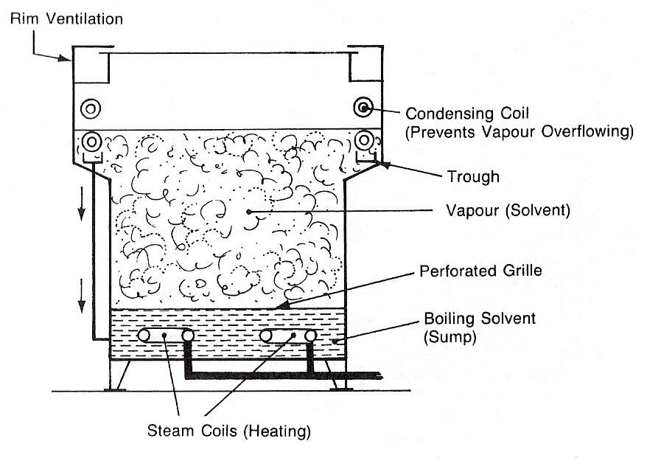
Figure 4 - Standard Vapour Degreasing Plant

LIQUOR DEGREASING
If dirt as well as oil or grease has to be removed, immersion of the work in boiling liquid solvent is more effective than vapour treatment. It is often preferred for the removal of tenacious fine polishing or lapping compounds.

Surface Protection of Materials
Some common metals when exposed to the atmosphere protect themselves by forming a chemical of mineralised coating on their surface. In the case of iron and steel, however, the metal will corrode, or rust as it is usually called. It is therefore necessary to protect these metals with some form of corrosion-resistant coating.

Painting
This is the easiest, cheapest and most common method of applying a protective coating. It is essential both for effective corrosion resistance and surface finish that the surface is correctly prepared before painting takes place.
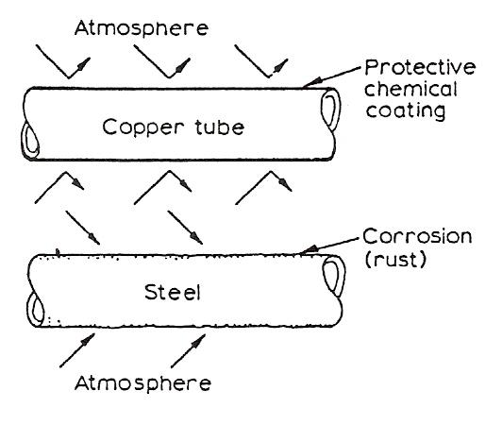
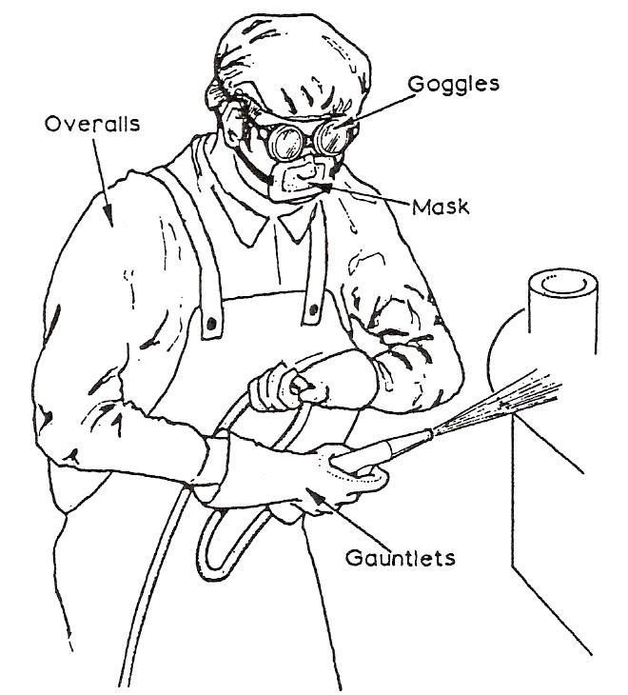
Figure 5 - Operating a Shot Blast Requires Protective Clothing

Surface Preparation Methods
- Wire Brushing and Chipping
The best results are obtained if the surface has been allowed to weather before these methods are used.
- Grit or Shot Blasting
This is the most effective method used and it is essential for use on large outside work such as ships, large tanks, etc. There are great health hazards in this process and it is essential that the operator wears adequate protective clothing.
- Pickling
The metal to be painted is dipped into a bath of 5 % solution of sulphuric acid for 15 to 20 min. It is then washed in hot water and then dipped into a phosphoric acid solution for 3 to 5 min.
- Degreasing
The metal is dipped into a bath containing a solvent to remove grease, etc.

Priming
After preparation of the surface by one of the above methods it should be primed. The three main groups of primer paint are listed below:

- Chromate Pigments, such as zinc chromate or lead chromate.
- Lead Pigments, such as red lead.
- Metallic Pigments, such as zinc oxide.

Finishing Coats
It is necessary to build up a sufficiently thick layer to obtain adequate protection. Therefore it is necessary to apply a further two or three coats.

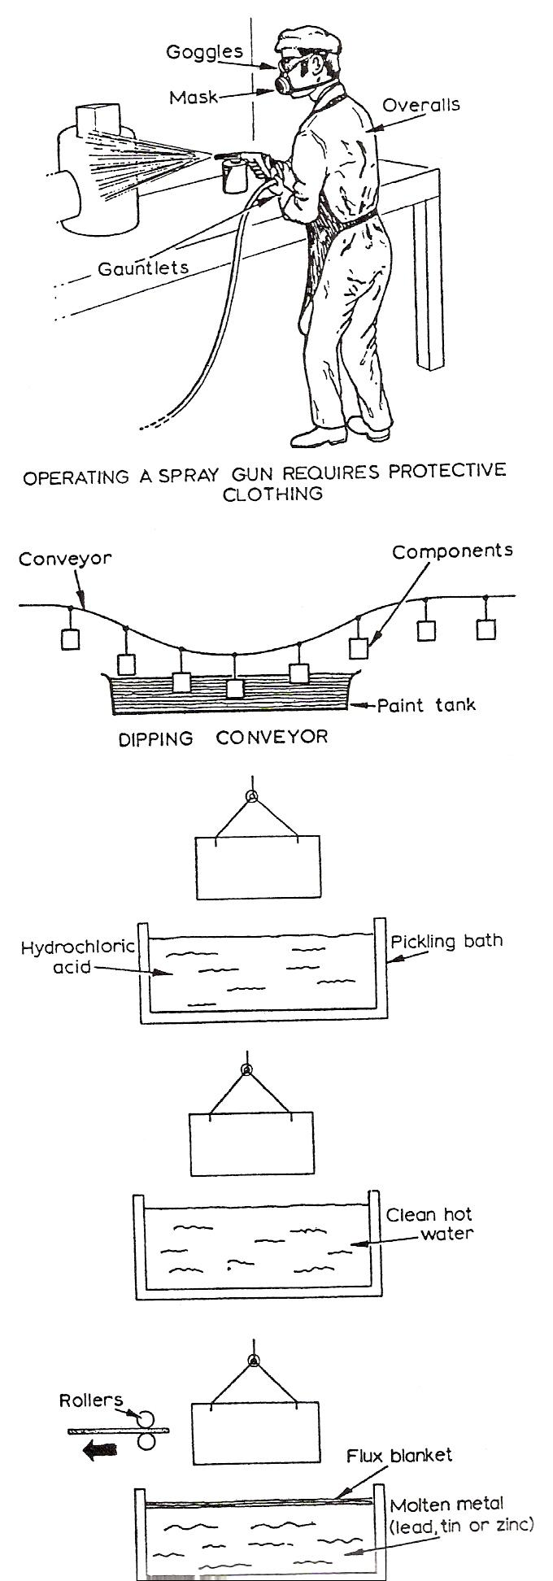
Methods of Applying Paint
- By Hand Application.
By brushing or by using hand rollers.
- By Spraying
Adequate safety precautions should be observed with this process and the operator should wear protective clothing.
- By Dipping
Suitable sized components can be coated by this method.
- Mechanically Operated Rollers
This method is suitable for use on large sheets which can be passed between rollers fed with a supply of paint.

Maintenance
All painted surfaces should be inspected regularly and any necessary repairs undertaken.

Metallic Coating
Lead, tin and zinc, which protect them by forming oxides on their surface, are used as protective coatings on steel. The metal coating may be applied to a fabricated component or to strip or sheet steel.

Hot Dip Galvanising
As shown opposite, the plate is pickled in a hot water bath. It is then passed through a flux blanket into the molten zinc. On removal it is passed through brushes or rollers to obtain the desired surface finish.

Tin Plating
This is not as effective as galvanising, but it is used extensively in the food container industry, since tin has non-toxic properties.

Metal Spraying
A special type of spray gun is used to coat the surface with a thin layer of tin, lead, zinc or aluminium. It is important when using this process that the surface to be coated is scrupulously clean. The cleaning method usually being shot or grit blasting.

Self Assessment

Index

G
Galvanising, Painting & Shot Blasting, 8
Blast Cleaning, 11
Flame Descaling, 12
Metal Degreasing, 12
Pickling, 10
Surface Preparation, 10
S
Self Assessment, 18
Surface Protection of Materials, 15
Finishing Coats, 16
Hot Dip Galvanising, 17
Maintenance, 17
Metal Spraying, 17
Metallic Coating, 17
Methods of Applying Paint, 17
Painting, 15
Priming, 16
Surface Preparation Methods, 16
Tin Plating, 17

